Camp Fees

Application & Deposit Fee: $100.00 per camper $150 for siblings)
Sessions | Tuition
Session I 8:35 a.m.-3:00 p.m.  (June 29-July 24) | $1,185.00- (Tadpoles only)  $1,155.00
Session II 8:35 a.m.-3:00 p.m.  (July 27-August 21) | $1,185.00- (Tadpoles only)  $1,155.00
Camp Groups | Rates
Tadpoles | $315.00
Grasshopper/Fireflies | $305.00
Before care (7:30-8:35 am) | $65 per session, $30 weekly,  $10 daily drop-in fee
Aftercare (3:00-6:00pm) | $250.00 per session, $75.00 weekly, $35 daily drop-in fee
½ Day (8:35 am-12:30pm) | $1,020/$1,030 (Tadpoles)
Field Trips: Additional Fees Are Based on Field Trip Site Fees
Pizza Days: Friday Is Pizza Day (optional) $3.00 per a camper (cash only)
Fees above reflect pool fees which includes admission and transportation.
Any registration received after June 8th will incur a $8 weekly fee surcharge pd w/ cash only

Camp Location
52 Randolph Rd ~ Silver Spring, MD, 20904

CAMP GROUPS FOR MORE INFORMATION:
Tadpoles: 2 & 3 years old CAMP DIRECTOR:
Grasshoppers: 3 & 4 years old VALERY SPRIGGS
Fire Flies: 5-10 years old (301)384-3131
WWW.JAMONMONTESSORI.COM

Summer Camp Theme: “A PASSPORT TO THE WORLD”
Week 1: USA Week 5: AUSTRALIA
Week 2: CHINA Week 6: INDIA
Week 3: NIGERIA Week 7: FRANCE
Week 4: COLUMBIA Week 8: THE NETHERLANDS

Camp Supplies
- Lunch (disposable items, including lunch bags)
- Backpack
- Change of Clothes
- Sneakers (sandals are not recommended)
- Linen for Cots (tadpoles & grasshoppers)
- Diapers/Pull-Ups, as needed

Glenmont Pool “Swim Day” Supplies
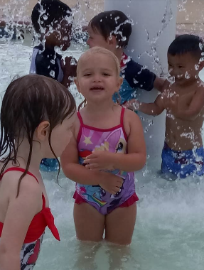
- Pool Shoes
- Bathing Suit (wear to camp)
- Towels
- Change of Clothes
(label all camper's belongings)
*Swimmers for Pool/if not Potty-Trained
* Energy Ready to Have Some Summer Splash Fun!

Testimonials:
“Our children attended Jamon Adventure Camp and had a ball! The program is well thought out, our children learned a lot while having fun. They were super excited, yet exhausted from all of the fun activities when I would pick them up!”
R. Gaston
“Jamon Adventure Camp is an anomaly. It was difficult to find an enriching, summer fun program for my 3 & 5-year-old children. My children loved their summer at Jamon Adventure Camp and I highly recommend it for families with younger campers!”
D. Faine

Enrollment Forms

Application, Camp Contract & $100.00 deposit
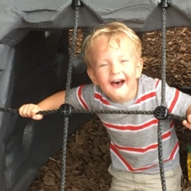
  - Emergency Contact Information

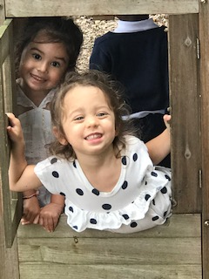
  - Health Inventory Forms
  - Immunizations Records
  - Permission Slips
Camp Schedule
7:30am-8:35 am Early Bird Care
8:35 am-9:00am Camp Meeting
9:00am-11:30am Rotation I & II
11:30am-12:00pm Outdoor Play
12:00pm-12:40pm Picnic lunch *outside weather permitting
12:40pm-1:00pm Clean up & Bathroom
1:00pm-3:00pm Naptime for Tadpoles & Grasshoppers
Rotation III for fireflies
3:00pm-6:00pm Rotation III & IV Extended Care *additional fees

Daily Rotations:
Spanish Immersion, S.T.E.M., Sports, Arts & Crafts
A Few of Our Special Past Guests Include!
The Maryland Zoo, Karate, Color Me Mine, Mad Scientist,
Mary-Go-Round, Petting Farm, Tennis Club, Dance Workshop

